**NETWORK SECURITY TOOL: HYDRA**

**Introduction:**

Hydra is a popular open-source password cracking tool that is used for performing brute force and dictionary attacks on various login systems and protocols. It is highly flexible and supports multiple attack modes, making it a valuable tool for security professionals, penetration testers, and ethical hackers.

**FEEATURES OF HYDRA:**

* Multi-protocol support

Hydra supports many login protocols, including SSH, RDP, HTTP, HTML forms.

* Brute-force capabilities

Hydra can systematically test every possible character combination to crack passwords.

* Dictionary attacks

Hydra can use pre-configured or custom dictionaries to attempt commonly used passwords.

* Parallel execution

Hydra can launch multiple login attempts at the same time to reduce testing time.

* Customization options

Hydra allows users to customize attack parameters like usernames, passwords, and attack modes.

* Modularity and extensibility

Hydra supports additional modules and plugins to cover new protocols and attack vectors.

* Ease of installation

Hydra is available in penetration testing toolkits like Kali Linux and Attack Box, and can be installed through standard package management systems.

* Flexibility

Hydra can adapt its approach based on the service being attacked.

Hydra is commonly used by penetration testers to identify vulnerabilities in client systems.

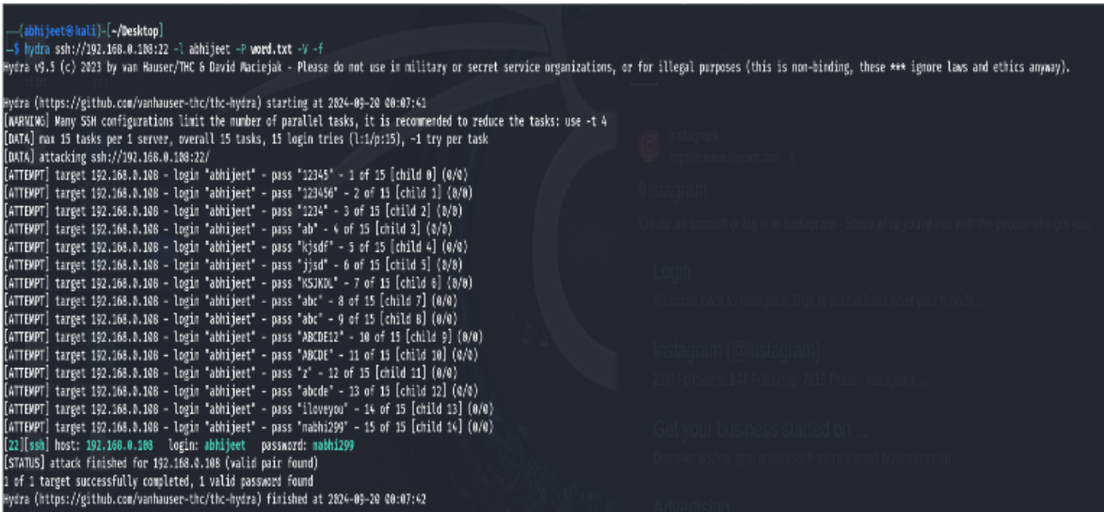

Options - target a target to attack, can be an IPv4 address, IPv6 address or DNS name.

Service -a service to attack, see the list of protocols available

**OPTIONAL SERVICE PARAMETER**

**-R** restore a previously aborted session. Requires a hydra.restore

file was written. Options are restored, but can be changed by

setting them after -R on the command line

**-S** connect via SSL(Security Socket Layers)

**-O** use old SSL v2 and v3

**-s** PORT - if the service is on a different default port, define it here

**-l** LOGIN or -L FILE login with LOGIN name, or load several logins from

FILE

